**Report on Data Cleaning and Modeling Steps for Maven Toys Dataset**

**Data Cleaning:**

No missing values or duplicates were found.

Data types were validated and corrected where necessary.  
Removed the $ to avoid clutter when starting the visualization

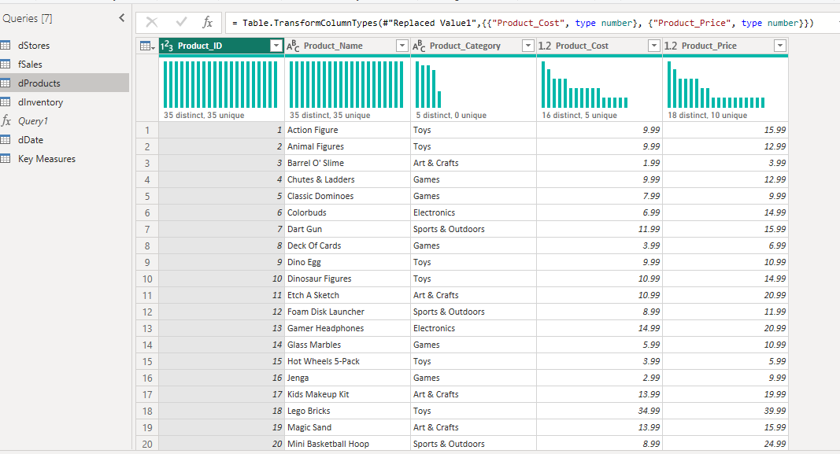

**Modeling:**

**Used a snowflake schema.**

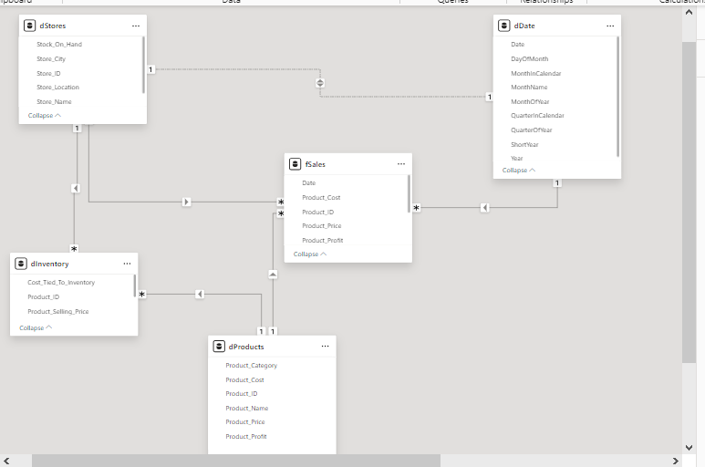

**Used a snowflake schema.**

fSales is the fact table, related to:

dInventory (inventory data).

dProducts (product data).

dStores (store data).

Date Dimension Table for date-related analysis.  
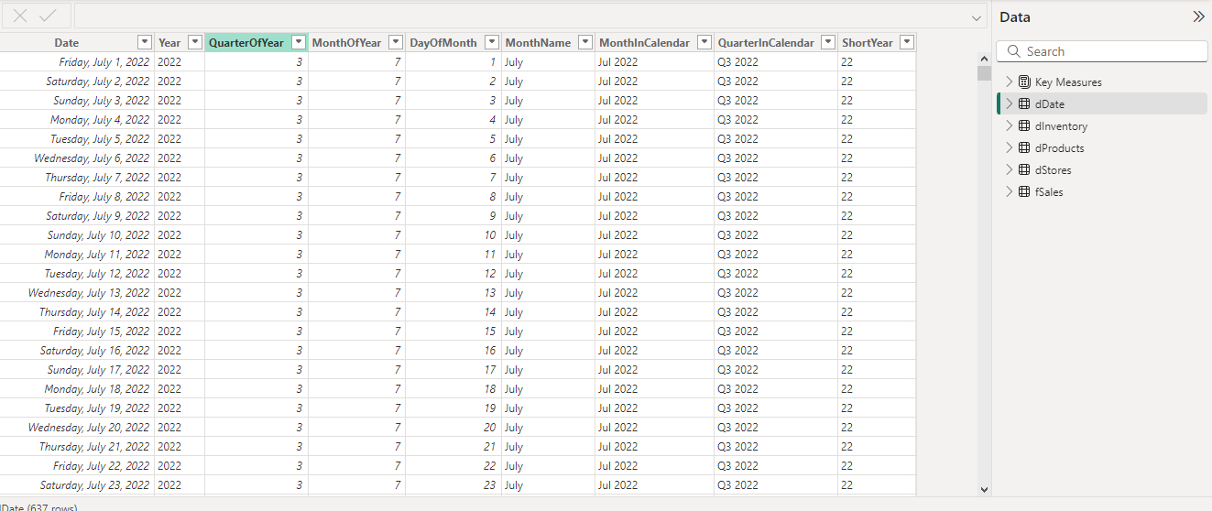

**Measures Created:**

Amount_Lost_in_Sales: Total lost sales due to stockouts.

CountofTop_10_Expensive_Products_Sold: Total units sold for the top 10 expensive products.

Product_CostX: Total cost of products sold.

Product_SalesX: Total revenue from product sales.

Product_ProfitX: Total profit from product sales.

Product_Ranking: Ranking of products based on sales value.

Total_Units_Sold: Total units sold across all products.